**SVKM’s NARSEE MONJEE INSTITUTE OF MANAGEMENT STUDIES**

# MUKESH PATEL SCHOOL OF TECHNOLOGY MANAGEMENT AND

# ENGINEERING

# A REPORT ON

# Delhi Air Quality Index

BY:

Akshit Naithani

SAP ID: 70022100234

COURSE: B(TECH.) COMPUTER ENGINEERING

Under the supervision of

**Prof. Suraj Patil**

(Asst. Professor, CS Department, MPSTME)

## Table of Contents

|  |  |
| --- | --- |
| Contents | Page  No |
| 1.1 Problem Statement | III |
| 1.2 Background of the Project Topic | III |
| 1.3 Dataset Description | III |
| 1.4 Software Tool Used | IV |
| 1.5 Business Scenario | IV |
| 1.6 Screenshots of Source code/Output | IV |
| 1.7 Conclusions | XIII |
| 1.8 References | XIII |

Problem Statement:

Delhi is one of the most polluted cities in the world. According to [www.earth.org](http://www.earth.org), it is the 4 most polluted cities in the world. Using this data-set we are going to analyse what makes Delhi’s air polluted.

Data-Set Chosen:



Data-Set Description:

Delhi Air Quality Index (2021-22) - This data-set contains various air contaminants present in Delhi with their indexes recorded everyday by hour from September of 2021 to September of 2022 meaning a data-set spanning over the course of a year. It shows indexes of Fine particulate matter (PM2.5) & (PM10), Nitrogen Oxide (NO), Nitrogen Di-Oxide (NO2), Nitrogen X-oxide (NOx ) and Carbon Monoxide (CO) present in air around Delhi from time to time.

Effects Of Air Contaminants:

Fine particulate matter (PM2.5)

Fine particulate matter (PM2.5) is an air pollutant which has particle sizes less than 2.5μ and are a concern for people's health when levels in air are high. Particles in the PM2.5 size range are able to travel deeply into the respiratory tract, reaching the lungs. Exposure to fine particles can cause short-term health effects such as eye, nose, throat and lung irritation, coughing, sneezing, runny nose and shortness of breath.

Fine particulate matter (PM10)

Short-term exposures to PM10 have been associated primarily with worsening of respiratory diseases, including asthma and chronic obstructive pulmonary disease (COPD), leading to hospitalization and emergency department visits.  The effects of long-term exposure to PM10 are less clear, although several studies suggest a link between long-term PM10 exposure and respiratory mortality.

Nitrogen Monoxide (NO)

Nitrogen monoxide (also called nitric oxide) is a chemical compound with the chemical formula NO that appears as a [colorless gas with a sharp, sweet odor](https://pubchem.ncbi.nlm.nih.gov/compound/Nitric-oxide" \l ":~:text=Nitric oxide or Nitrogen monoxide,automobile engines and power plants.). It is a [toxic air pollutant](https://pubchem.ncbi.nlm.nih.gov/compound/Nitric-oxide) produced by automobile engines and power plants. Breathing high concentrations of NO can make [respiratory diseases](https://www.kansashealthsystem.com/-/media/Files/PDF/More-Poisons/Nitric-Oxide.pdf) such as asthma much more serious and even lead to respiratory infections. People with asthma, children, and the elderly are at a greater risk of the health effects caused by NO.

Nitrogen Dioxide (NO2)

Nitrogen dioxide, or NO2, is a gaseous air pollutant composed of nitrogen and oxygen. NO2 can form indoors when fossil fuels like wood or natural gas are burned.Nitrogen dioxide causes a range of harmful effects on the lungs, including Increased inflammation of the airways, Worsened cough and wheezing, Reduced lung function, Increased asthma attacks and Greater likelihood of emergency department and hospital admission. New research warns that NO2 is likely to be a cause of asthma in children

Nitrogen Dioxide (NOx)

Nitrogen Oxides are a family of poisonous, highly reactive gases. These gases form when fuel is burned at high temperatures. NOx pollution is emitted by automobiles, trucks and various non-road vehicles (e.g., construction equipment, boats, etc.) as well as industrial sources such as power plants, industrial boilers, cement kilns, and turbines.

Carbon Monoxide (CO)

CO pollution occurs primarily from emissions produced by fossil fuel–powered vehicles. Exposure to lower levels of CO is most serious for those who suffer from heart disease, and can cause chest pain, reduce the ability to exercise, or—with repeated exposures—may contribute to other cardiovascular effects. People who breathe high levels of CO can develop vision problems, reduced ability to work or learn, reduced manual dexterity, and difficulty performing complex tasks. At very high levels, CO is poisonous and can cause death.

Code Executed:

#Libraries Used

library(ggplot2)

library(moments)

#Mode Function

my_mode <- function(x)

{

unique_x <- unique(x)

tabulate_x <- tabulate(match(x, unique_x))

unique_x[tabulate_x == max(tabulate_x)]

}

#Reading the Data-Set

df = read.csv("Delhi AQI V1.1.csv")

#Cleaning The Attributes

df$PM2.5 = ifelse(is.na(df$PM2.5),mean(df$PM2.5,na.rm = TRUE),df$PM2.5)

df$PM10 = ifelse(is.na(df$PM10),mean(df$PM10,na.rm = TRUE),df$PM10)

df$NO = ifelse(is.na(df$NO),mean(df$NO,na.rm = TRUE),df$NO)

df$NO2 = ifelse(is.na(df$NO2),mean(df$NO2,na.rm = TRUE),df$NO2)

df$NOx = ifelse(is.na(df$NOx),mean(df$NOx,na.rm = TRUE),df$NOx)

df$CO = ifelse(is.na(df$CO),mean(df$CO,na.rm = TRUE),df$CO)

#Analysis Of Data-Set

#PM2.5

#Max

max(df$PM2.5)

#Mean

mean(df$PM2.5)

#Median

median(df$PM2.5)

#Mode

my_mode(df$PM2.5)

#Standard Deviation

sd(df$PM2.5)

#Plotting PM2.5 Indexes

ggplot(df, aes(x= factor(From.Date) , y= PM2.5),main = 'PM2.5 index by Time',ylab = "PM2.5 Index", xlab = "Dates") + geom_jitter(width = 0.1, alpha = 0.5)

#Skewness Of PM2.5 Indexes

skewness(df$PM2.5,na.rm = TRUE)

#Kurtosis Of PM2.5 Indexes

kurtosis(df$PM2.5,na.rm = TRUE)

#PM10

#Max

max(df$PM10)

#Mean

mean(df$PM10)

#Median

median(df$PM10)

#Mode

my_mode(df$PM10)

#Standard Deviation

sd(df$PM10)

#Plotting PM10 Indexes

ggplot(df, aes(x= factor(From.Date) , y= PM10),main = 'PM10 index by Time',ylab = "PM10 Index", xlab = "Dates") + geom_jitter(width = 0.1, alpha = 0.5)

#Skewness Of PM10 Indexes

skewness(df$PM10,na.rm = TRUE)

#Kurtosis Of PM10 Indexes

kurtosis(df$PM10,na.rm = TRUE)

#NO

#Max

max(df$NO)

#Mean

mean(df$NO)

#Median

median(df$NO)

#Mode

my_mode(df$NO)

#Standard Deviation

sd(df$NO)

#Plotting NO Indexes

ggplot(df, aes(x= factor(From.Date) , y= NO),main = 'NO index by Time',ylab = "NO Index", xlab = "Dates") + geom_jitter(width = 0.1, alpha = 0.5)

#Skewness Of NO Indexes

skewness(df$NO,na.rm = TRUE)

#Kurtosis Of NO Indexes

kurtosis(df$NO,na.rm = TRUE)

#NO2

#Max

max(df$NO2)

#Mean

mean(df$NO2)

#Median

median(df$NO2)

#Mode

my_mode(df$NO2)

#Standard Deviation

sd(df$NO2)

#Plotting NO2 Indexes

ggplot(df, aes(x= factor(From.Date) , y= NO2),main = 'NO2 index by Time',ylab = "NO2 Index", xlab = "Dates") + geom_jitter(width = 0.1, alpha = 0.5)

#Skewness Of NO2 Indexes

skewness(df$NO2,na.rm = TRUE)

#Kurtosis Of NO2 Indexes

kurtosis(df$NO2,na.rm = TRUE)

#NOx

#Max

max(df$NOx)

#Mean

mean(df$NOx)

#Median

median(df$NOx)

#Mode

my_mode(df$NOx)

#Standard Deviation

sd(df$NOx)

#Plotting NOx Indexes

ggplot(df, aes(x= factor(From.Date) , y= NOx),main = 'NOx index by Time',ylab = "NOx Index", xlab = "Dates") + geom_jitter(width = 0.1, alpha = 0.5)

#Skewness Of NOx Indexes

skewness(df$NOx,na.rm = TRUE)

#Kurtosis Of NOx Indexes

kurtosis(df$NOx,na.rm = TRUE)

#CO

#Max

max(df$CO)

#Mean

mean(df$CO)

#Median

median(df$CO)

#Mode

my_mode(df$CO)

#Standard Deviation

sd(df$CO)

#Plotting CO Indexes

ggplot(df, aes(x= factor(From.Date) , y= CO),main = 'CO index by Time',ylab = "CO Index", xlab = "Dates") + geom_jitter(width = 0.1, alpha = 0.5)

#Skewness Of CO Indexes

skewness(df$CO,na.rm = TRUE)

#Kurtosis Of CO Indexes

kurtosis(df$CO,na.rm = TRUE)

Output Produced:

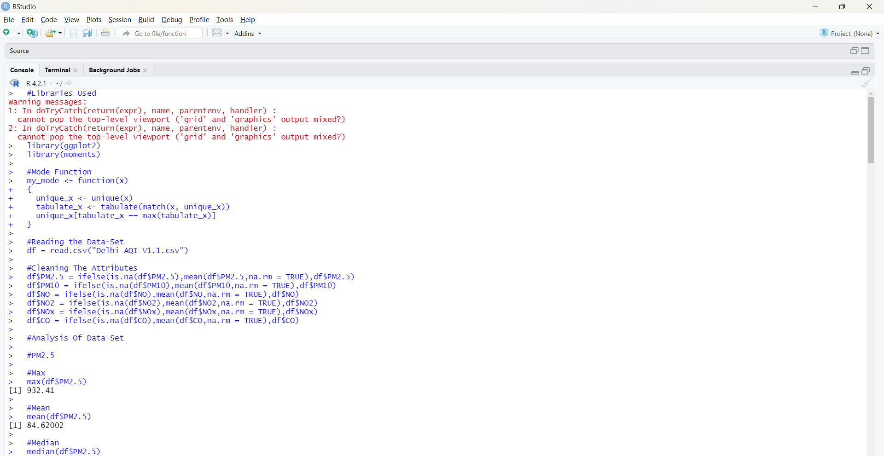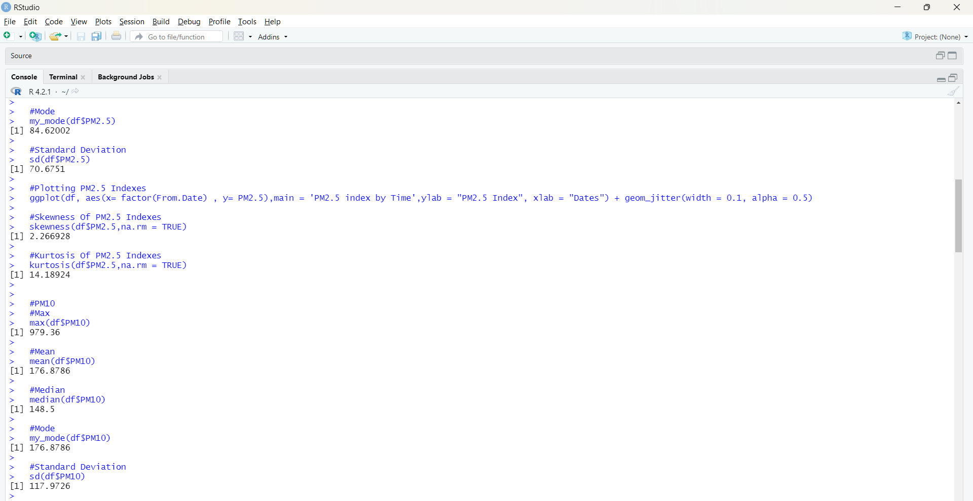

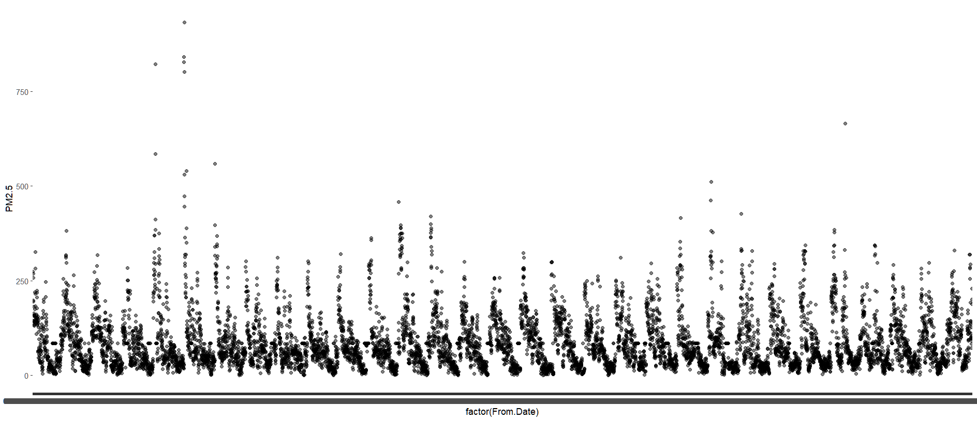

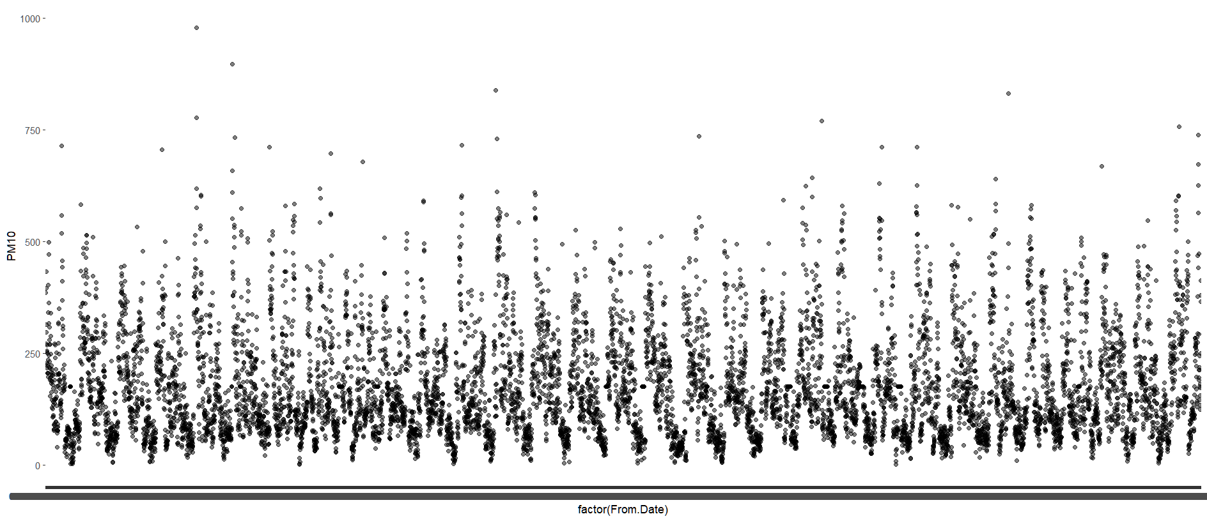

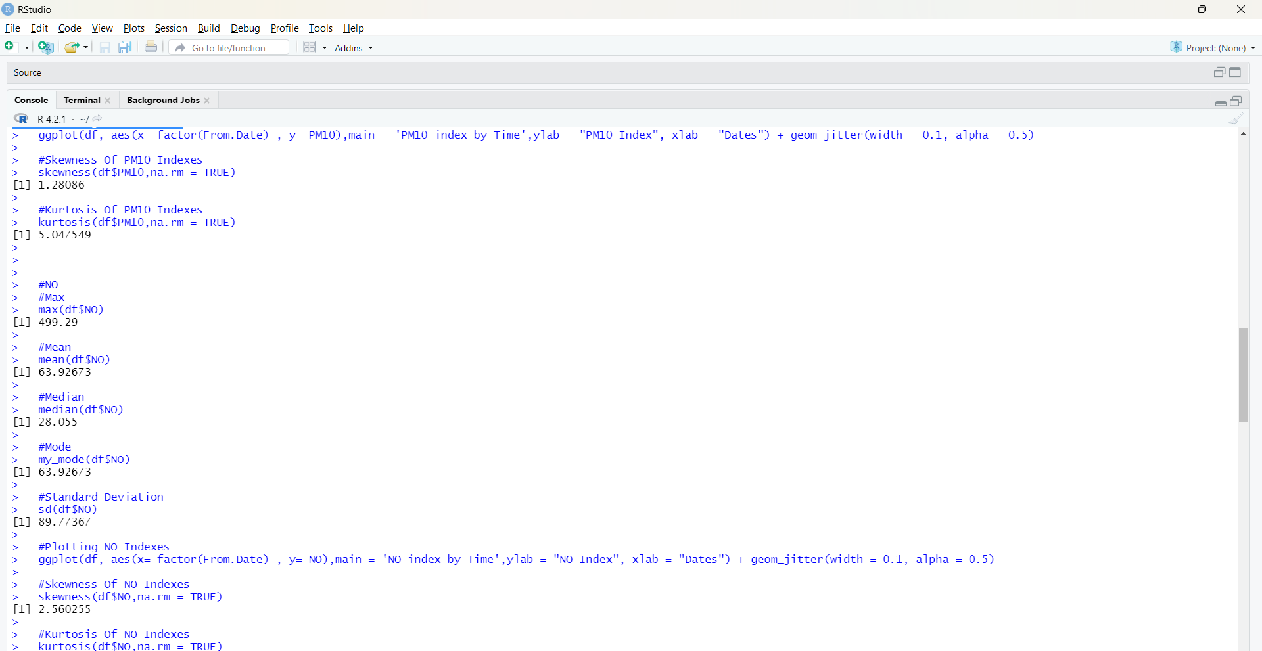

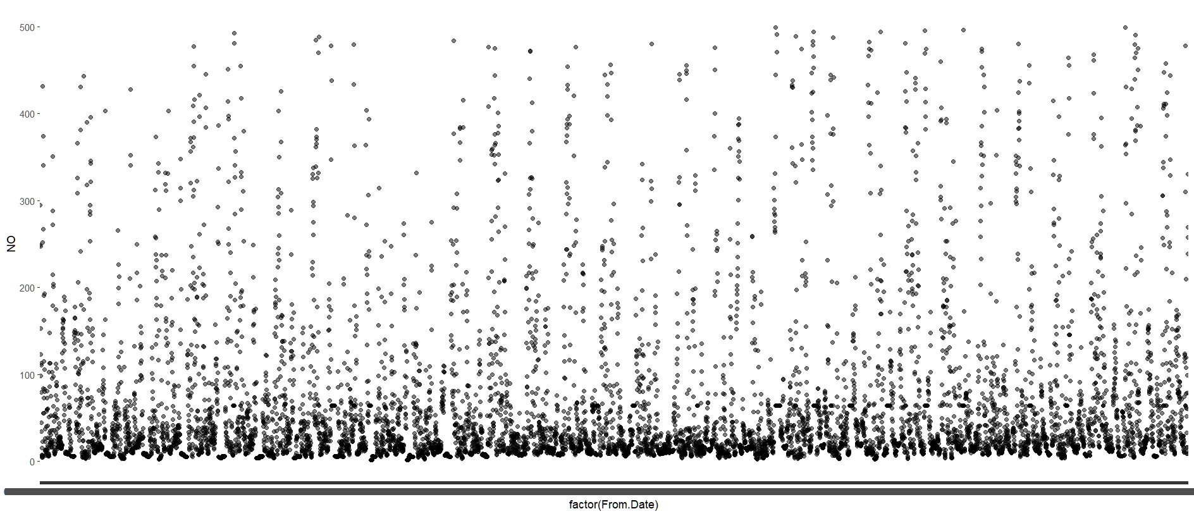

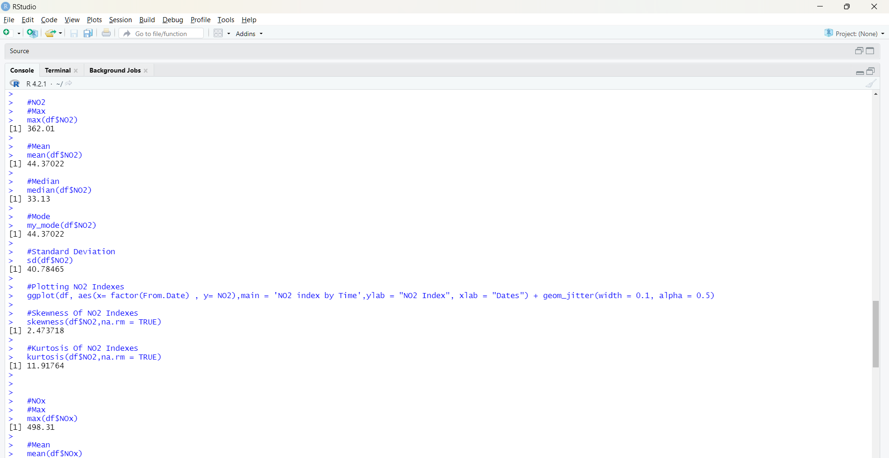

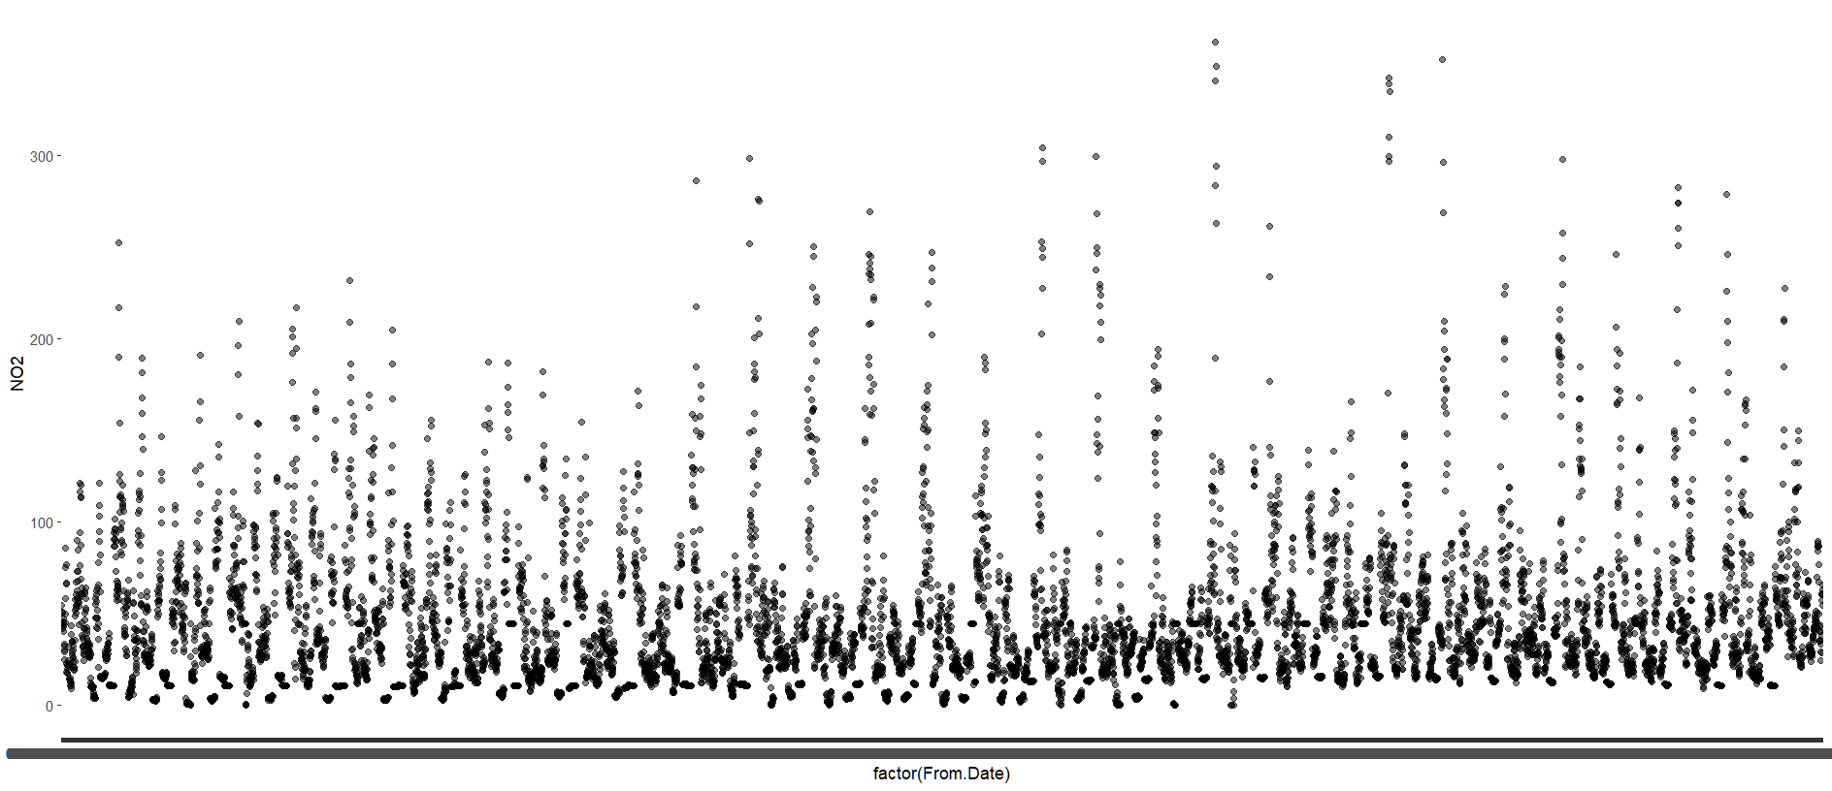

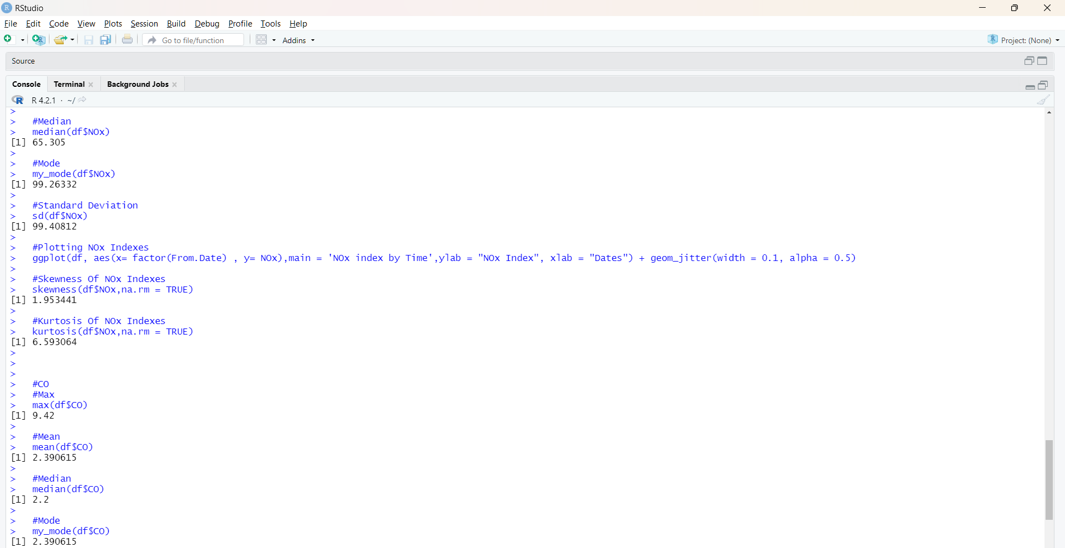

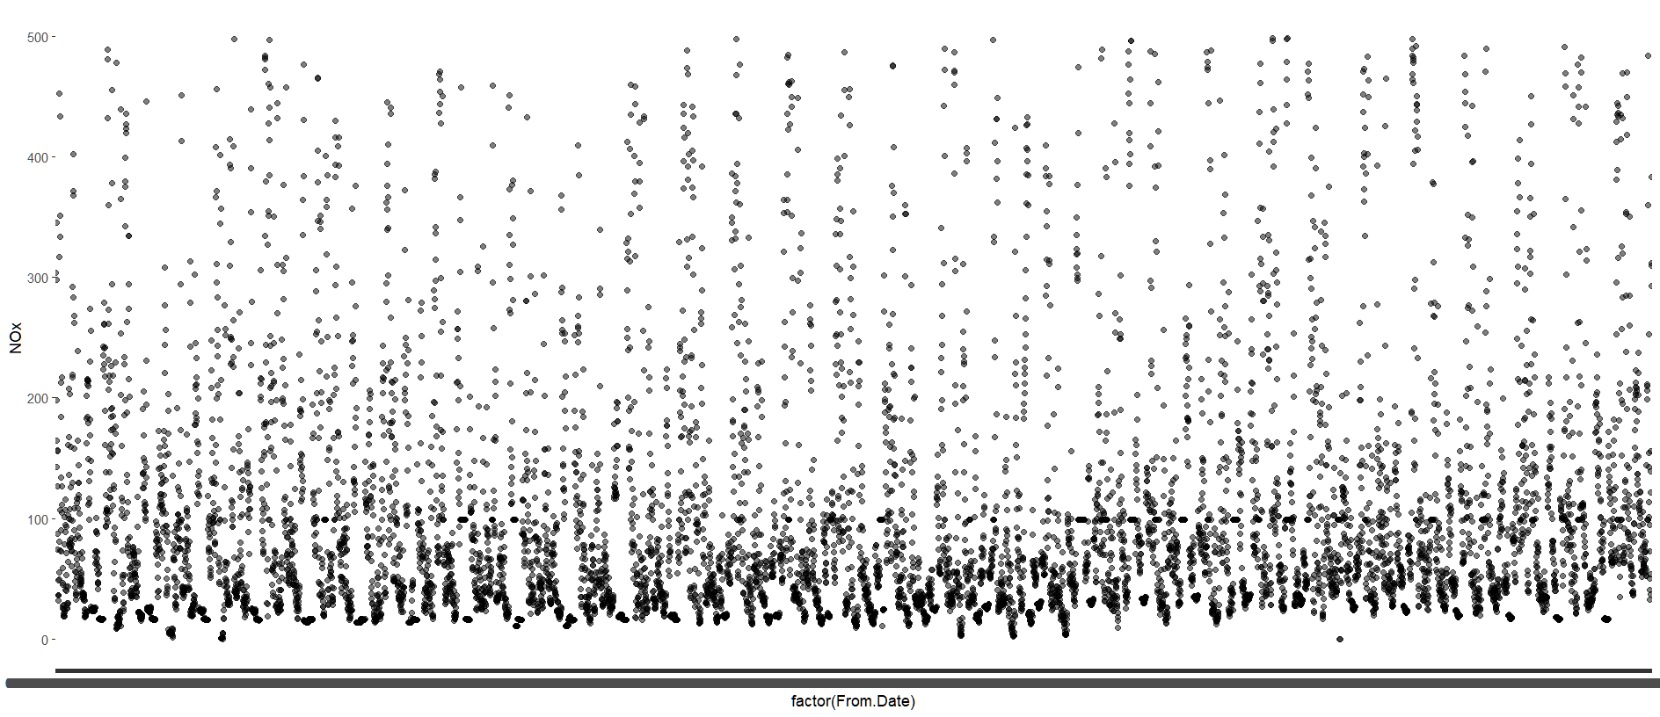

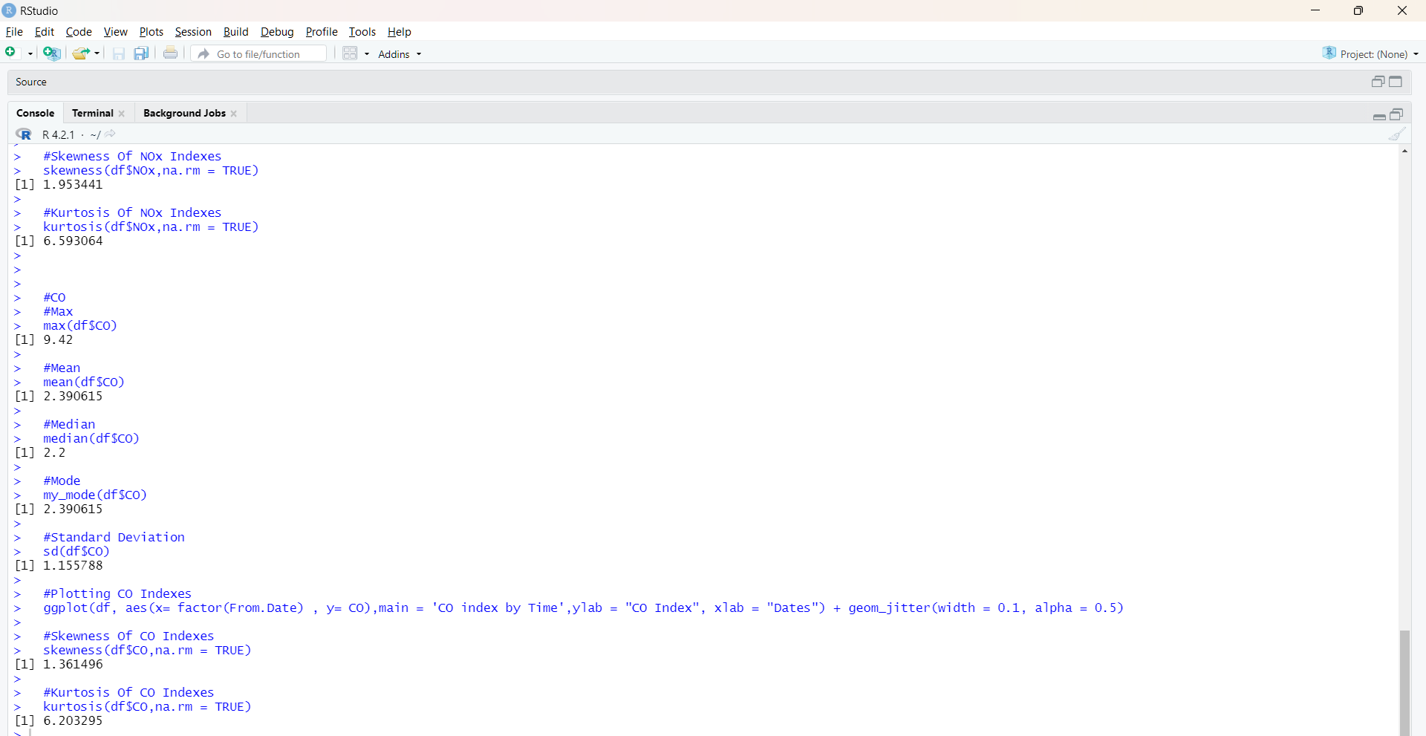

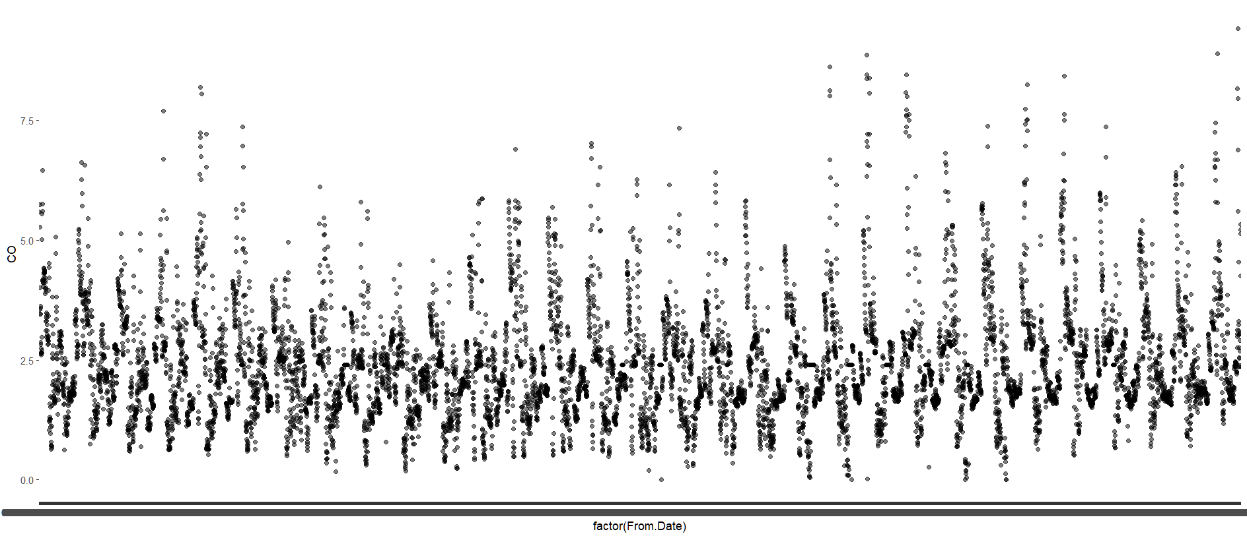

Observation:

We can see how worse is the quality of air in Delhi by the operations performed. The PM10 is the highest amount of index present in the air having an average of 176.8786 followed closely by NOx gases which is on average present 99.26332. The lowest of them is CO gas at 2.390615. We can see from the various charts that the indexes remain low at mornings and nights and peak in the afternoon since there is high traffic densities. We can also observe that there were higher indexes in 2022 than in 2021 due to the Covid-19 virus. As there lock-downs and people weren’t going out regularly, there was less pollution which leaded to pollution. In 2022 with the world resuming as it is, there was high population density which lead to increase in pollutants in Delhi.

Conclusion:

Delhi’s air quality is bad as it is and worsening at an alarming rate. The people and the government have to work together to resolve this problem of pollution else there will come a time when the city would be considered inhabitable.

References:

Data-set from - <https://www.kaggle.com/>

Information from - <https://www.airnow.gov/aqi/aqi-basics/#:~:text=Think%20of%20the%20AQI%20as,300%20represents%20hazardous%20air%20quality.>

<https://blissair.com/what-is-pm-2-5.htm>

<https://ww2.arb.ca.gov/resources/inhalable-particulate-matter-and-health#:~:text=Particles%20are%20defined%20by%20their,or%20less%20in%20diameter%20(PM2.>

<https://www.tceq.texas.gov/airquality/sip/criteria-pollutants/sip-co#:~:text=CO%20is%20a%20colorless%2C%20odorless,as%20construction%20equipment%20and%20boats).>